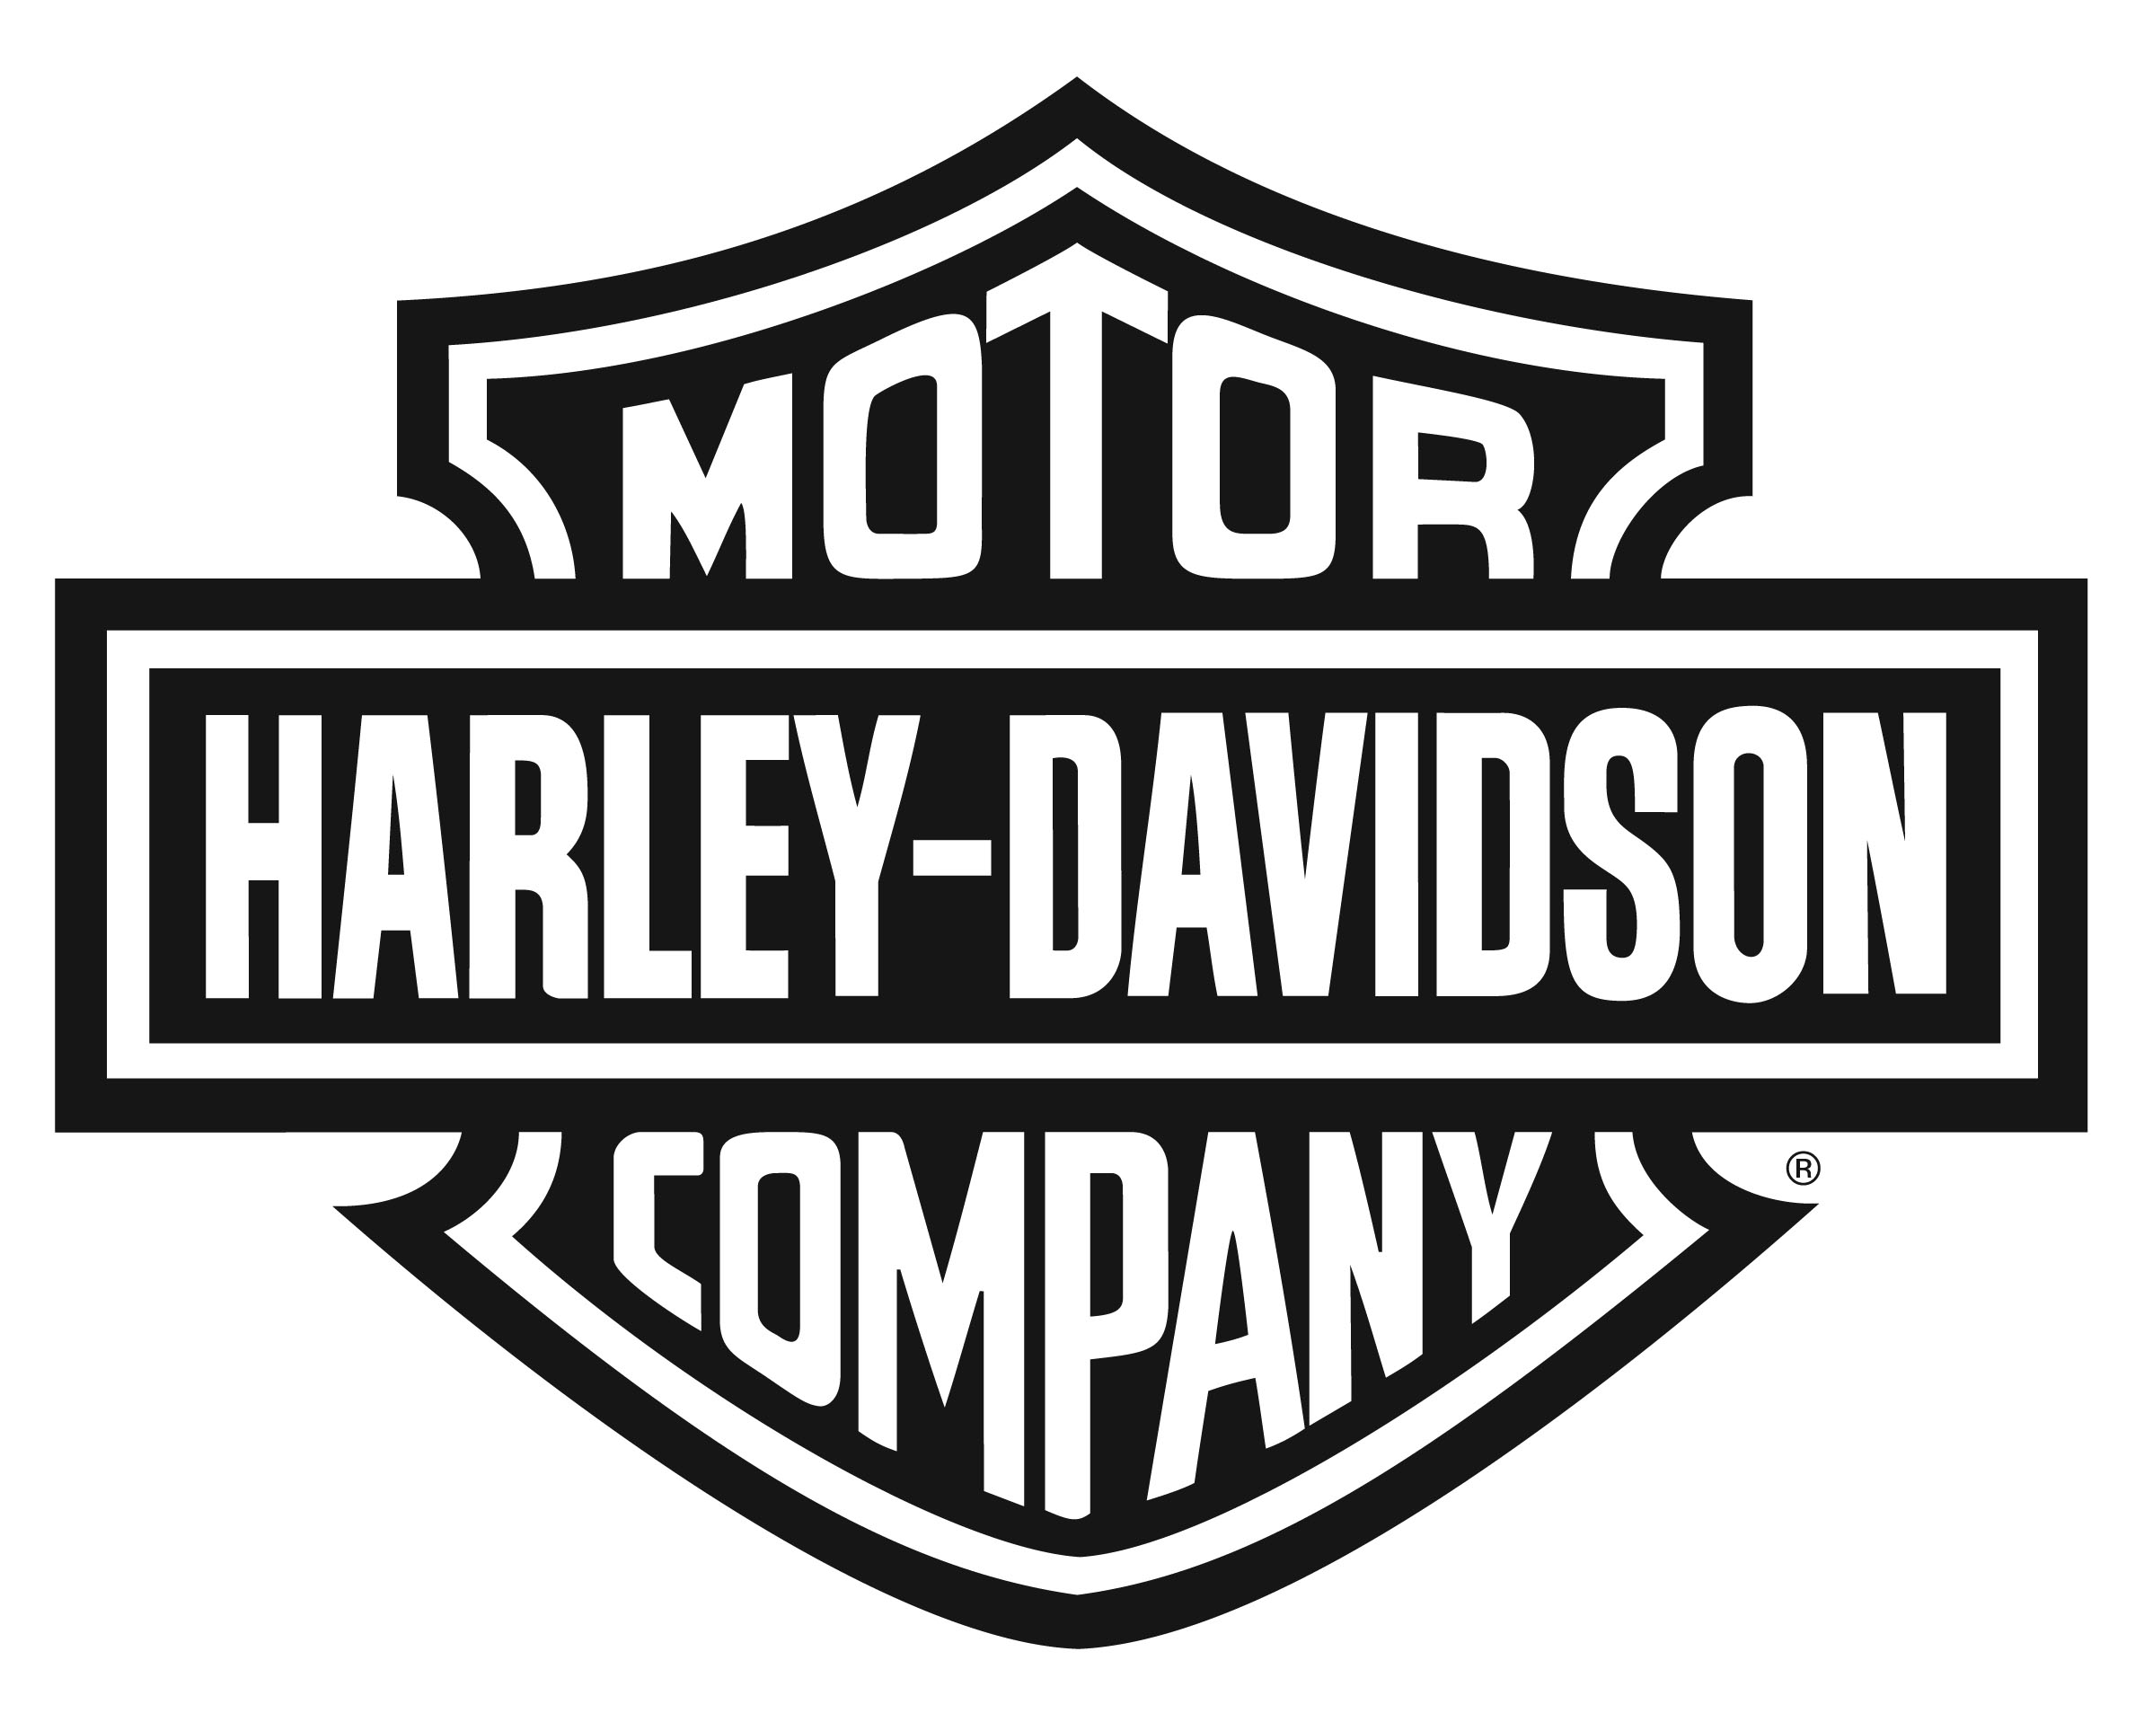
Harley-Davidson Europe Ltd
Oxford Business Park, 6000 Garsington Road, Oxford, UK. OX4 2DQ

NEWS

MORE POWER, MORE TORQUE, MORE HORSEPOWER – HARLEY-DAVIDSON® RELEASES NEW SCREAMIN’ EAGLE® PERFORMANCE MUFFLERS FOR SPORTSTER® OWNERS

OXFORD - March 16, 2015 – Harley-Davidson® Sportster® owners in Europe, the Middle East and Africa can now unleash more power and torque from their bikes with the release of street-legal Screamin’ Eagle® performance mufflers from Harley-Davidson.

Now available through the Harley-Davidson dealer network and fully CE certified for legal road use, Screamin’ Eagle Street Cannon Performance mufflers deliver 5% more horsepower over standard mufflers, and a further 10% performance improvement when coupled with a Screamin’ Eagle Stage 1 air cleaner.

“Sportster owners love street performance,” said Calum McKechnie, Marketing Manager, Parts, Accessories & Motorclothes, Harley-Davidson EMEA. “Ask a Sportster owner what improvements they’d love for their motorcycle and the answer is likely to be more power, more torque, more speed – and a great sound. Well, 2015 is the year that Sportster owners can unleash even more of the true potential of their motorcycles with significant performance gains in rear-wheel horsepower and torque, and a fantastic – but still street legal – sound.”

The new high flow 3.25” Street Cannon mufflers, available in chrome or jet black heat-resistant ceramic finish, are a welcome return to the European performance exhaust market for Harley-Davidson. Specifically designed to provide aggressive performance gains throughout the range while releasing more of the distinctive sound of the Harley-Davidson V-twin engine, the new mufflers are now available in Harley-Davidson dealers located in countries across Europe, the Middle East, and Africa.

Further power and performance gains are possible by combining the new mufflers with complementary parts from the Screamin’ Eagle range of performance and tuning parts including, air cleaner kits and covers, header pipes, exhaust wraps, and end caps. Each part in the Screamin’ Eagle range is specifically designed by Harley-Davidson engineers to perform perfectly together.

Screamin’ Eagle mufflers are available for Sportster models including Iron 883™, 883R, SuperLow® , 1200 Custom , Forty - Eight® and Seventy-Two™.

###

About Harley-Davidson Motor Company®
Harley-Davidson Motor Company produces heavyweight custom, cruiser and touring motorcycles and offers a complete line of Harley-Davidson® motorcycle parts, accessories, riding gear and apparel, and general merchandise. For more information, visit Harley-Davidson’s website at www.h-d.com

